**DAILY ONLINE ACTIVITIES SUMMARY**

|  |  |  |  |  |  |  |  |  |
| --- | --- | --- | --- | --- | --- | --- | --- | --- |
| **Date:** | **31-05-2020** | | | | | **Name:** | **Shiza Amreen.J** | |
| **Sem & Sec** | **4th sem B sec** | | | | | **USN:** | **4AL18CS078** | |
| **Online Test Summary** | | | | | | | | |
| **Subject** | | **-** | | | | | | |
| **Max. Marks** | | **-** | | **Score** | | | **-** | |
| **Certification Course Summary** | | | | | | | | |
| **Course** | **Python for Machine Learning** | | | | | | | |
| **Certificate Provider** | | | **GreatLearning** | | **Duration** | | | **5 Hours** |
| **Coding Challenges** | | | | | | | | |
| **Problem Statement: Write a Java program to calculate nPr** | | | | | | | | |
| **Status: completed** | | | | | | | | |
| **Uploaded the report in Github** | | | | | **yes** | | | |
| **If yes Repository name** | | | | | **Lockdown_Coding** | | | |
| **Uploaded the report in slack** | | | | | **yes** | | | |

Certification Course Details:

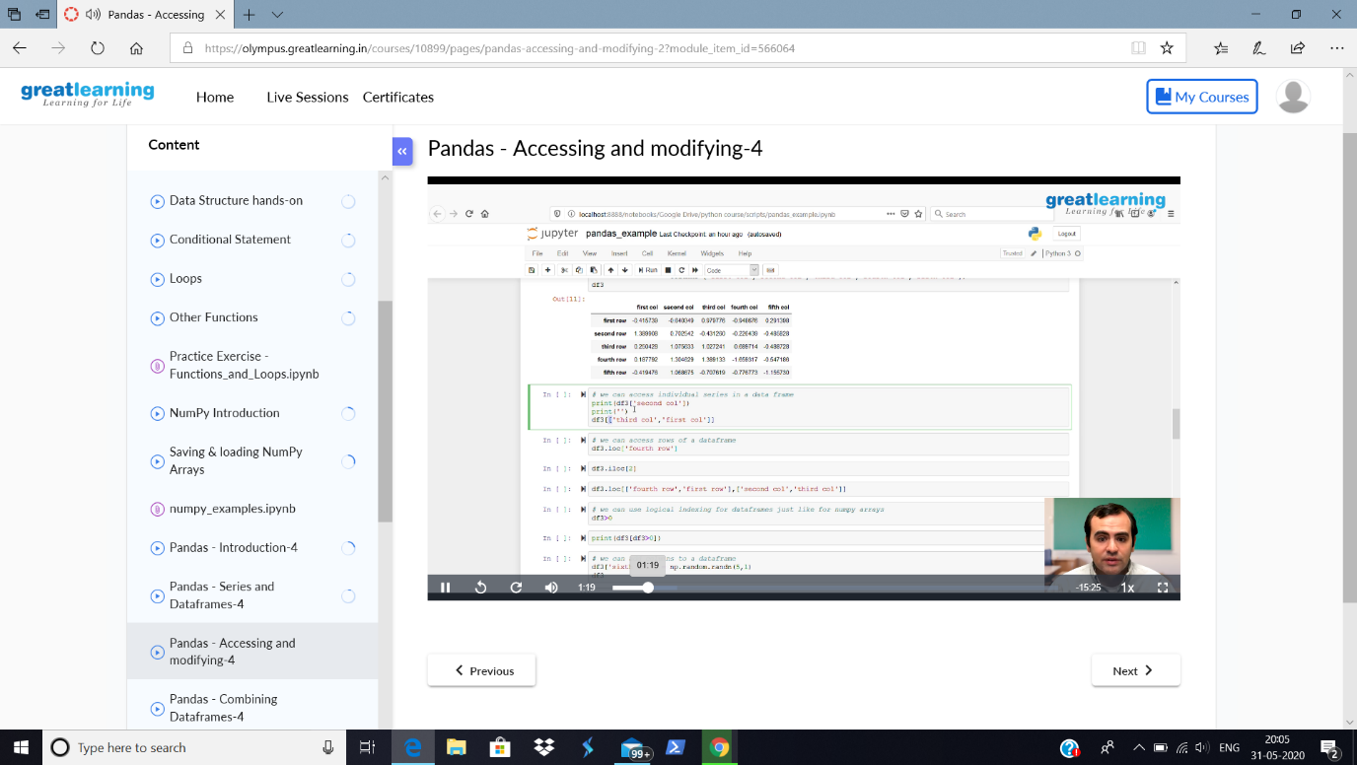

Today, in the course Python for Machine Learning, I have gone through the concepts of Pandas-Accessing and Modifying.

Coding Challenges Details:

**Problem Statement: Write a Java program to calculate nPr**

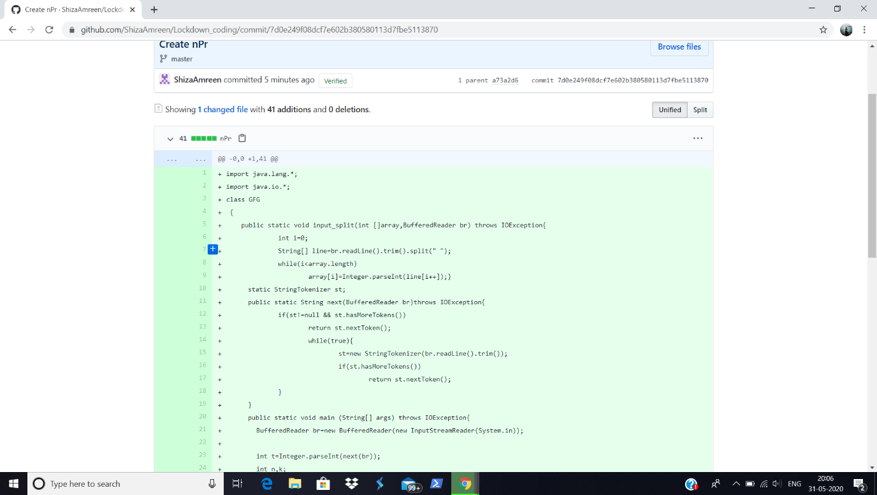

**I have written the code for given problem statement and uploaded it in my github repository, Lockdown_Coding.**

<https://github.com/ShizaAmreen/Lockdown_coding/commit/7d0e249f08dcf7e602b380580113d7fbe5113870>